**1. Navigate to CloudWatch**

1. **Login to AWS Management Console**.
2. **Navigate to CloudWatch**.

**2. Create a New Dashboard**

1. In the CloudWatch console, click on **Dashboards** in the left navigation pane.
2. Click on **Create dashboard**.
3. Enter a **Name** for your dashboard (e.g., EC2-Monitoring).
4. Click on **Create dashboard**.

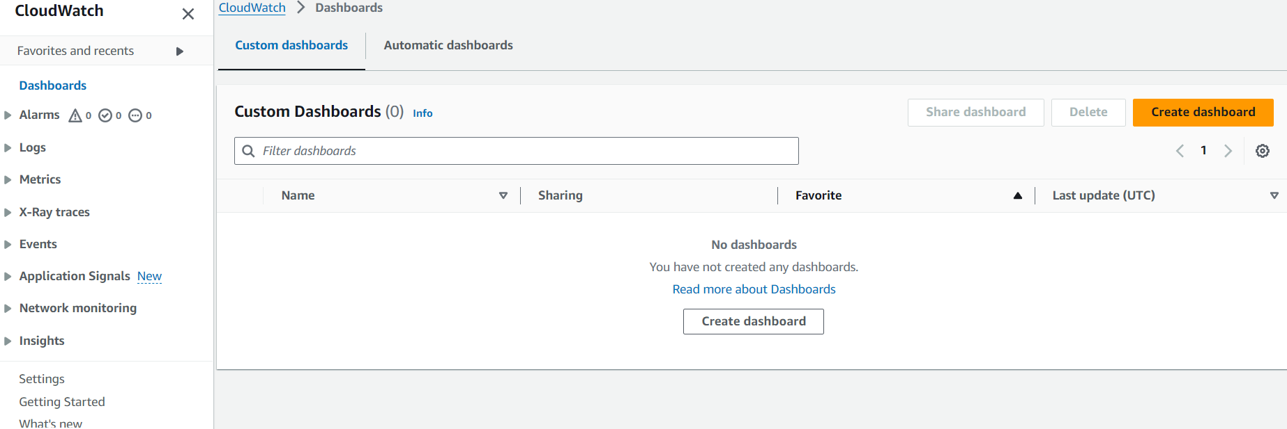

**3. Add Widgets for CPU Utilization and Networking**

**Step 1: Add CPU Utilization Widget**

1. In the **Add widget** dialog, select **Line**.
2. Click on **Configure**.

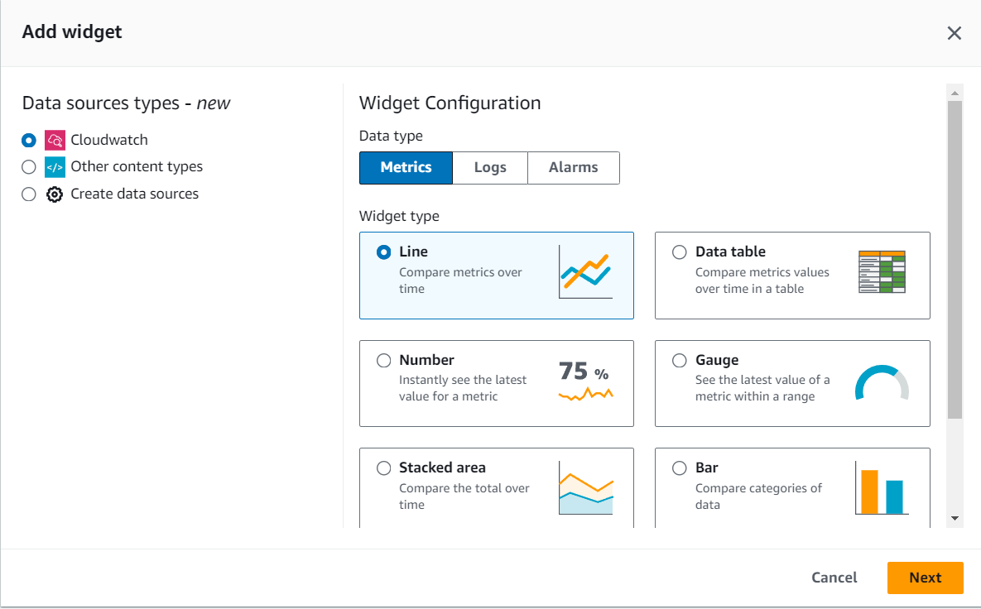

1. In the **Search** bar, type EC2 and select **Per-Instance Metrics**.
2. Find and select your specific EC2 instance.

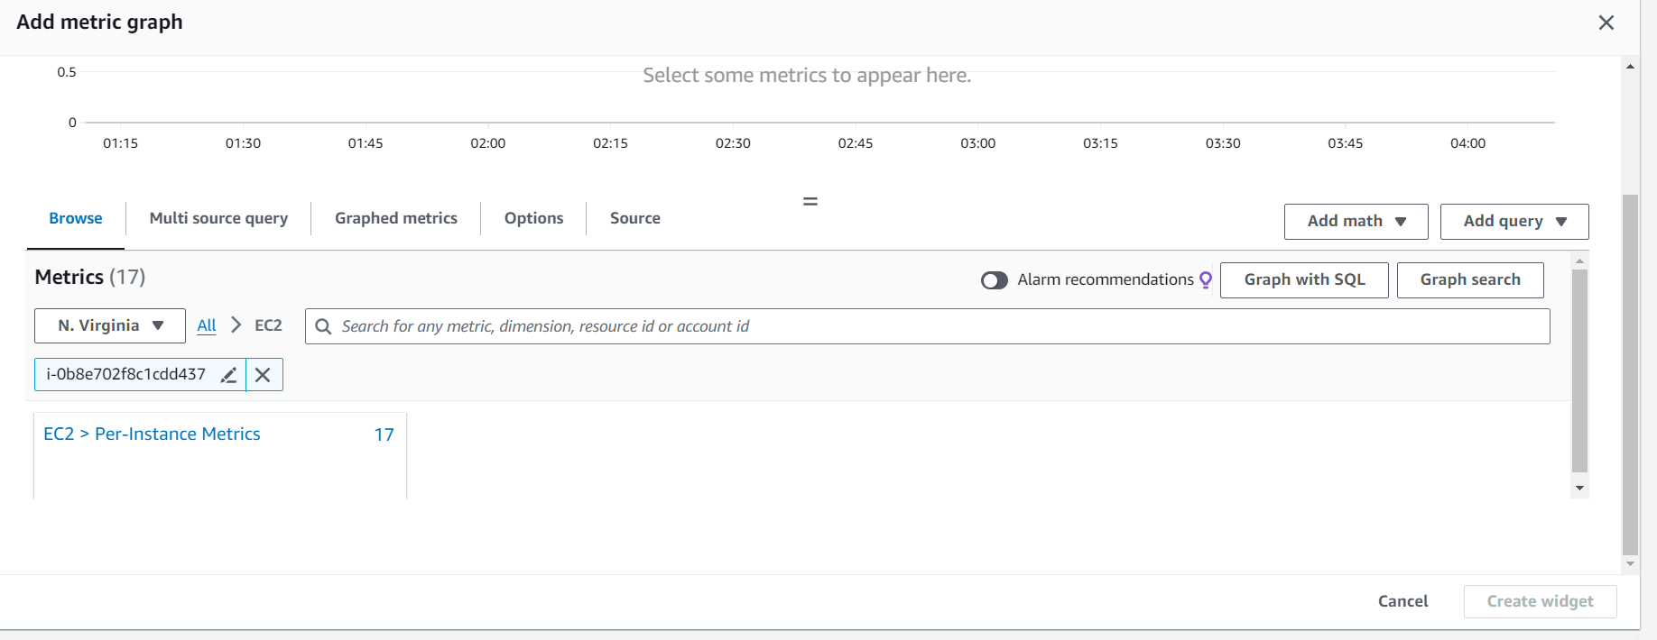

1. In the **Metric name** column, check the box for CPUUtilization.

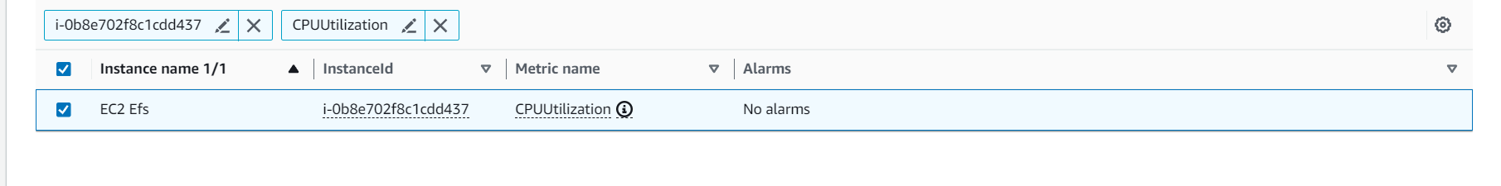

1. Click on **Create widget**.

**Step 2: Add Networking Widget**

1. Click on **Add widget** again.
2. Select **Line** and click on **Configure**.
3. In the **Search** bar, type EC2 and select **Per-Instance Metrics**.
4. Find and select your specific EC2 instance.
5. In the **Metric name** column, check the boxes for:
   * NetworkIn
   * NetworkOut

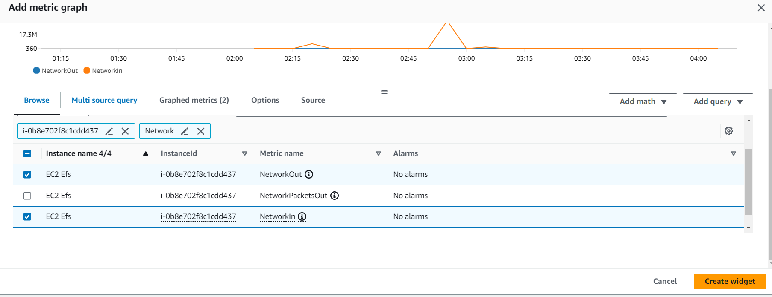

1. Click on **Create widget**.

**4. Customize and Save the Dashboard**

1. Arrange the widgets as desired by dragging and resizing them.
2. Click on **Save dashboard**.
3. **Verify the Dashboard**

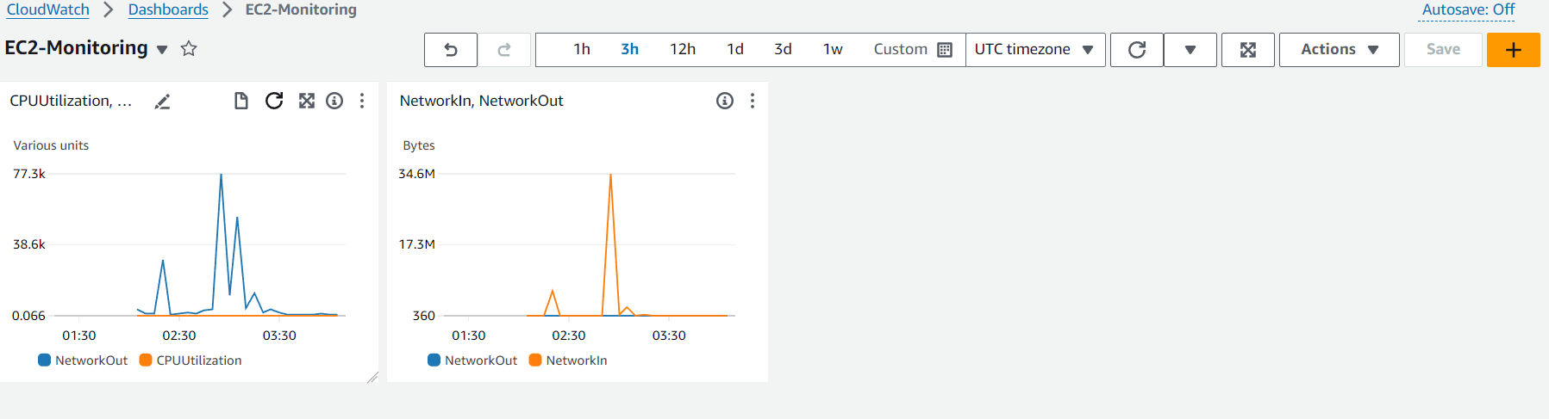

1. Ensure that the CPU utilization and networking metrics are being displayed correctly.
2. You can click on each widget to drill down into more detailed data and adjust the time range as needed.

**Summary**

* **Created a new CloudWatch dashboard**.
* **Added widgets for CPU utilization and networking** for a specific EC2 instance.
* **Arranged and saved the dashboard** for easy monitoring.